# JAYPEE INSTITUTE OF INFORMATION TECHNOLOGY NOIDA-128

**SOFTWARE DEVELOPMENT LAB**



**PROJECT ON-**

**RESTAURANT MANAGMENT SYSTEM**

**GROUP MEMBER DETAILS: SUBMITTED TO:**

**Anandita Dua-9920103145-f5 Mrs Swati Gupta**

**Mrs Shilpa Budhkar**

# Restaurant Management System

# Introduction :-

Restaurant is a kind of business that serves people all over the world with ready made food. Many restaurants have a lot of difficulty in managing the business such as customer ordering and reservation of tables. By using manual customer ordering it is difficult for the waiter to keep the correct customer information and the information may get lost . The current system (manual system) is not effective and efficient to use anymore. The current system cannot save, manage and monitor the restaurant methodically enough. We need a better restaurant management system in place. This system is developed to automate day to day activity of a restaurant and provide service facilities to restaurants and also to the customer.

# Objectives :-

The main point of developing this system is to help restaurant administrators manage the restaurant business and help customers for ordering and reserving tables digitally. This restaurant management system can be used by employees in a restaurant to handle the clients, their orders and can help them easily find free tables or place orders. Digital restaurant management systems will help the restaurant administrator to manage restaurant management more efficiently and provide various services to the customers that would make their experience more delightful.

# Services Provided :-

This restaurant management system provide various services like:-

* **Reservation Service**

Customers can reserve the table that they want as well as access their already reserved table. The system also informs the customer whether the table that they have selected is available for reservation or not.

* **Display of Menu**

The system displays a systematic menu of the items available at the restaurant along with the price of the respective item. The menu is organised into various categories such as salads, desserts, soups, beverages etc.

* **Dine In**

If a customer does not have an already reserved table, the system allows the customer to select an available table for them to dine in at.

* **Ordering**

The system allows the client to place their orders easily. The client is allowed to keep ordering and reordering items from the menu as many times they want and stop when they are done and don’t want to place any further orders.

* **Bill Generation**

The system calculates and generates a systematic bill according to the price and quantity of items ordered by the customer. It also allows the user to use their coupons if they have any and get a discount on the amount that they have to pay.

* **Accepts Information from the User**

The system accepts the customer’s important information like name, contact number, address and the mode of payment and prints this information on their bill.

* **About the Restaurant**

The system allows the user to access certain information about the restaurant like the name of the owner, manager, year of establishment etc.

***Class Diagram :-***

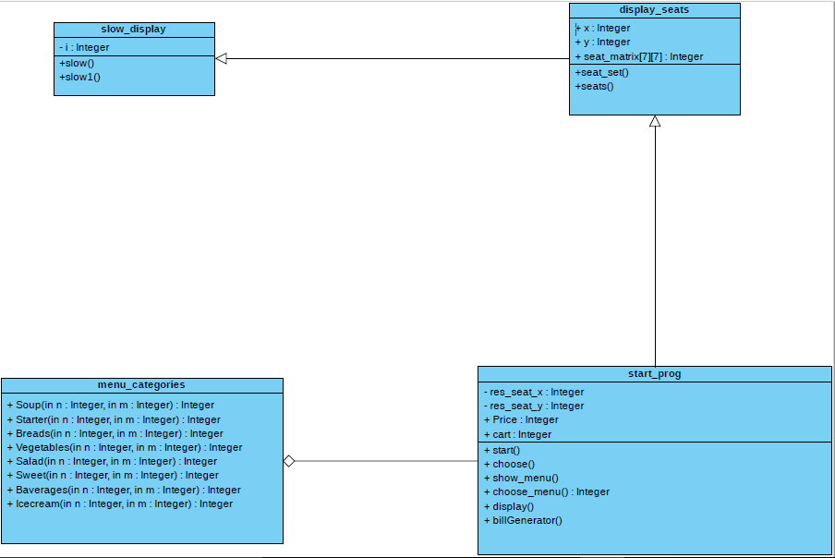

**Lines of code :- 1094**

***Code :-***

#include <bits/stdc++.h>

using namespace std;

class slow_display

{

int i;

public:

void slow()

{

for (i = 0; i < 10000000; i++)

{

cout << "";

}

}

void slow1()

{

for (i = 0; i < 99999900; i++)

{

cout << "";

}

}

};

class display_seats: public slow_display

{

public:

int x, y;

int seat_matrix[7][7];// to display seats in retro!

void seat_set()

{

int i, j;

for (i = 0; i <= 6; i++)

{

for (j = 0; j <= 6; j++)

{

if((i>=1 && i<=5) && (j>=1 && j<=5))

seat_matrix[i][j] = 0;

else

seat_matrix[i][j] = 99;

}

}

}

void seats() //seat matrix

{

int i, j;

for (i = 0; i <= 6; i++)

{

for (j = 0; j <= 6; j++)

{

if ((i == 0 && j == 0) || (i == 6 && j == 0))

{

slow();

cout << "\t =======";

}

else if (i == 0 || i == 6)

{

slow();

cout << "=======";

}

else if (j == 0)

{

slow();

cout << "\t|| ";

}

else if (j == 6)

{

slow();

cout << "\t || ";

}

else

{

slow();

cout << "\t" << seat_matrix[i][j];

}

}

cout << "\n";

}

another_choice:

cout << "\tEnter row and column::";

cin >> x >> y;

if (seat_matrix[x][y] == 0)

seat_matrix[x][y] = 1;

else if((x<=0 || x>5 || y<=0 || y>5))

{

cout<<"\n\tThe seat number you are requesting does not exist."<<endl;

goto another_choice;

}

else

{

cout << "\n\tSorry Sir ,this seat is already booked.\n\tPlease choose some other seat\n ";

goto another_choice;

}

for (int i = 0; i <= 6; i++)

{

for (int j = 0; j <= 6; j++)

{

if ((i == 0 && j == 0) || (i == 6 && j == 0))

{

slow();

cout << "\t =======";

}

else if (i == 0 || i == 6)

{

slow();

cout<<"=======";

}

else if ((i == x) && (j == y))

{

slow();

cout << "\t" << seat_matrix[i][j];

}

else if (j == 0)

{

slow();

cout << "\t|| ";

}

else if (j == 6)

{

slow();

cout << "\t || ";

}

else

{

cout << "\t" << seat_matrix[i][j];

}

}

cout << "\n";

}

}

};

class menu_categories //to display menu

{

public:

int Soup(int n, int m) //price of different soup

{

cout << "\t\t *************************************** \n";

cout << "\t\t| |\n";

cout << "\t\t| |\n";

cout << "\t\t| |\n";

cout << "\t\t| |\n";

cout << "\t\t| Dish:- Unit:- |\n";

cout << "\t\t| |\n";

cout << "\t\t| |\n";

switch (n)

{

case 1:

{

cout << "\t\t| 1.Tomato Soup " << m << " |\n";

break;

}

case 2:

{

cout << "\t\t| 2.Spinach Soup " << m << " |\n";

break;

}

case 3:

{

cout << "\t\t| 3.Sweetcorn Soup " << m << " |\n";

break;

}

case 4:

{

cout << "\t\t| 4.Hot&Sour Soup " << m << " |\n";

break;

}

default:

{

cout << "\t\t|=====Wrong input! Please try again=====|\n";

}

}

cout << "\t\t| |\n";

cout << "\t\t| |\n";

cout << "\t\t| |\n";

cout << "\t\t| |\n";

cout << "\t\t| |\n";

cout << "\t\t *************************************** \n";

return 0;

}

int Starter(int n, int m)//price of different starter

{

cout << "\t\t *************************************** \n";

cout << "\t\t| |\n";

cout << "\t\t| |\n";

cout << "\t\t| |\n";

cout << "\t\t| |\n";

cout << "\t\t| Dish:- Unit:- |\n";

cout << "\t\t| |\n";

cout << "\t\t| |\n";

switch (n)

{

case 1:

{

cout << "\t\t| 1.Cocktail Samosa " << m << " |\n";

break;

}

case 2:

{

cout << "\t\t| 2.Veg Patties " << m << " |\n";

break;

}

case 3:

{

cout << "\t\t| 3.Veg Roll " << m << " |\n";

break;

}

case 4:

{

cout << "\t\t| 4.Veg Manchurian " << m << " |\n";

break;

}

default:

{

cout << "\t\t|=====Wrong input! Please try again=====|\n";

}

}

cout << "\t\t| |\n";

cout << "\t\t| |\n";

cout << "\t\t| |\n";

cout << "\t\t| |\n";

cout << "\t\t| |\n";

cout << "\t\t *************************************** \n";

return 0;

}

int Breads(int n, int m)//price of different breads

{

cout << "\t\t *************************************** \n";

cout << "\t\t| |\n";

cout << "\t\t| |\n";

cout << "\t\t| |\n";

cout << "\t\t| |\n";

cout << "\t\t| Dish:- Unit:- |\n";

cout << "\t\t| |\n";

cout << "\t\t| |\n";

switch (n)

{

case 1:

{

cout << "\t\t| 1.Chapati " << m << " |\n";

break;

}

case 2:

{

cout << "\t\t| 2.Paratha " << m << " |\n";

break;

}

case 3:

{

cout << "\t\t| 3.Naan " << m << " |\n";

break;

}

case 4:

{

cout << "\t\t| 4.Kulcha " << m << " |\n";

break;

}

case 5:

{

cout << "\t\t| 5.Bhatura " << m << " |\n";

break;

}

default:

{

cout << "\t\t|=====Wrong input! Please try again=====|\n";

}

}

cout << "\t\t| |\n";

cout << "\t\t| |\n";

cout << "\t\t| |\n";

cout << "\t\t| |\n";

cout << "\t\t| |\n";

cout << "\t\t *************************************** \n";

return 0;

}

int Vegetables(int n, int m)//price of different vegeatbles

{

cout << "\t\t *************************************** \n";

cout << "\t\t| |\n";

cout << "\t\t| |\n";

cout << "\t\t| |\n";

cout << "\t\t| |\n";

cout << "\t\t| Dish:- Unit:- |\n";

cout << "\t\t| |\n";

cout << "\t\t| |\n";

switch (n)

{

case 1:

{

cout << "\t\t| 1.Veg Makhani " << m << " |\n";

break;

}

case 2:

{

cout << "\t\t| 2.Paneer Kadhaai " << m << " |\n";

break;

}

case 3:

{

cout << "\t\t| 3.Paneer Mattar " << m << " |\n";

break;

}

default:

{

cout << "\t\t|=====Wrong input! Please try again=====|\n";

}

}

cout << "\t\t| |\n";

cout << "\t\t| |\n";

cout << "\t\t| |\n";

cout << "\t\t| |\n";

cout << "\t\t| |\n";

cout << "\t\t *************************************** \n";

return 0;

}

int Salad(int n, int m)//price of different salad

{

cout << "\t\t *************************************** \n";

cout << "\t\t| |\n";

cout << "\t\t| |\n";

cout << "\t\t| |\n";

cout << "\t\t| |\n";

cout << "\t\t| Dish:- Unit:- |\n";

cout << "\t\t| |\n";

cout << "\t\t| |\n";

switch (n)

{

case 1:

{

cout << "\t\t| 1.Green Salad " << m << " |\n";

break;

}

case 2:

{

cout << "\t\t| 2.Alu Chat " << m << " |\n";

break;

}

case 3:

{

cout << "\t\t| 3.Russian Salad " << m << " |\n";

break;

}

default:

{

cout << "\t\t|=====Wrong input! Please try again=====|\n";

}

}

cout << "\t\t| |\n";

cout << "\t\t| |\n";

cout << "\t\t| |\n";

cout << "\t\t| |\n";

cout << "\t\t| |\n";

cout << "\t\t *************************************** \n";

return 0;

}

int Sweet(int n, int m)//price of different sweet

{

cout << "\t\t *************************************** \n";

cout << "\t\t| |\n";

cout << "\t\t| |\n";

cout << "\t\t| |\n";

cout << "\t\t| |\n";

cout << "\t\t| Dish:- Unit:- |\n";

cout << "\t\t| |\n";

cout << "\t\t| |\n";

switch (n)

{

case 1:

{

cout << "\t\t| 1.Gulaab Jaamun " << m << " |\n";

break;

}

case 2:

{

cout << "\t\t| 2.Rasgulla " << m << " |\"<<m<<";

break;

}

case 3:

{

cout << "\t\t| 3.Gaajar Halwa " << m << " |\n";

break;

}

case 4:

{

cout << "\t\t| 4.Shri Kand " << m << " |\n";

break;

}

case 5:

{

cout << "\t\t| 5.Jalebi " << m << " |\n";

break;

}

default:

{

cout << "\t\t|=====Wrong input! Please try again=====|\n";

}

}

cout << "\t\t| |\n";

cout << "\t\t| |\n";

cout << "\t\t| |\n";

cout << "\t\t| |\n";

cout << "\t\t| |\n";

cout << "\t\t *************************************** \n";

return 0;

}

int Baverages(int n, int m)//price of different baverages

{

cout << "\t\t *************************************** \n";

cout << "\t\t| |\n";

cout << "\t\t| |\n";

cout << "\t\t| |\n";

cout << "\t\t| |\n";

cout << "\t\t| Dish:- Unit:- |\n";

cout << "\t\t| |\n";

cout << "\t\t| |\n";

switch (n)

{

case 1:

{

cout << "\t\t| 1.Cold drink " << m << " |" << endl;

break;

}

case 2:

{

cout << "\t\t| 2.Cold Coffee " << m << " |" << endl;

break;

}

case 3:

{

cout << "\t\t| 3.Tea " << m << " | " << endl;

break;

}

case 4:

{

cout << "\t\t| 4.Hot Coffee " << m << " | " << endl;

break;

}

default:

{

cout << "\t\t|=====Wrong input! Please try again=====|\n";

}

}

cout << "\t\t| |\n";

cout << "\t\t| |\n";

cout << "\t\t| |\n";

cout << "\t\t| |\n";

cout << "\t\t| |\n";

cout << "\t\t *************************************** \n";

return 0;

}

int Icecream(int n, int m)//price of different ice cream

{

cout << "\t\t *************************************************** \n";

cout << "\t\t| |\n";

cout << "\t\t| |\n";

cout << "\t\t| |\n";

cout << "\t\t| |\n";

cout << "\t\t| Dish:- Unit:- |\n";

cout << "\t\t| |\n";

cout << "\t\t| |\n";

switch (n)

{

case 1:

{

cout << "\t\t| 1.Vanilla " << m << " |";

break;

}

case 2:

{

cout << "\t\t| 2.Strawberry " << m << " |";

break;

}

case 3:

{

cout << "\t\t| 3.Chocolate " << m << " |";

break;

}

case 4:

{

cout << "\t\t| 4.Vanilla with chocolate sauce " << m << " |";

break;

}

default:

{

cout << "\t\t|===========Wrong input! Please try again===========|\n";

}

}

cout << "\t\t| |\n";

cout << "\t\t| |\n";

cout << "\t\t| |\n";

cout << "\t\t| |\n";

cout << "\t\t| |\n";

cout << "\t\t *************************************************** \n";

return 0;

}

};

class start_prog : public display_seats //Choosing and reservation of seat

{

int res_seat_x, res_seat_y;

public:

int Price;

int cart;

menu_categories* menu;

void start()

{

cout << "\t\t\t\t\t\t\t*********************************\n";

cout << "\t\t\t\t\t\t\tWelcome to Annapurna Restaurant \n";

cout << "\t\t\t\t\t\t\t*********************************\n\n\n";

cout << "\t�If more of us valued food and cheer and song above hoarded gold, it would be a merrier world.�\n\n";

cout << "\n\n\tWelcome to our Restaurant.\n\n";

seat_set();

choose();

}

void choose() //function for reservation of seat

{

cout << "\tWhat would you like to do:\n\n";

cout << "\t1:Dine-in\n\t2:Reservation of seat\n\t3:Already Reserved\n\t4:About Us\n";

int choice_1;

cout << "\tEnter you choice::";

cin >> choice_1;

switch (choice_1)

{

case 1:

cout << "\tFor Dine-in ,Please Choose Your Seat\n";

seats();

slow1();

cout << "\tCongratulations! Your seat has been booked\n";

slow1();

slow1();

slow1();

slow1();

show_menu();

display();

fflush(stdin);

break;

case 2:

cout << "\tFor Reservation Please Choose Your Seats\n";

seats();

cout << "\tCongratulations! Your seat has been booked\n";

fflush(stdin);

choose();

break;

case 3:

cout << "\tPlease tell your seat number::";

cin >> res_seat_x >> res_seat_y;

cout << "\tThank you Sir ,You Are On time\n";

if (seat_matrix[res_seat_x][res_seat_y] == 1)

{

cout << "\n\tPlease Have Your Seat\n";

slow1();

slow1();

slow1();

show_menu();

display();

}

else

{

cout << "\n\tSorry sir, but there is no seat booked with this number\n";

cout << "\n\tPlease visit us again\n\n\n";

start();

}

break;

case 4:

cout << "\n\n\t\t\t*********************************************************\n\n";

cout << "\t\t\t\t<<<<<< || A N N A P U R N A || >>>>>>\t\t\t\t\n\n\n";

cout << "\t\t\tDirector::Mr.Divyansh Govil \t\t Estd : 1995\n";

cout << "\t\t\tOwner::Mr.Piyush Gupta\n";

cout << "\t\t\tCordinator::Ms.Anandita\n";

cout << "\t\t\tTotal chefs::10\n";

cout << "\t\t\tTotal Servants::20\n";

cout << "\t\t\tManager::Mr.Gaurav Kesarwani\n\n";

cout << "\t\t\t*********************************************************\n\n";

cout << "\t\t"

"We have been serving mouth-watering delicacies to our customers since 1995.\n\t\tWe always aspire to provide excellent services to our customers.\n\n\n\n";

choose();

break;

default:

cout << "\n\tSir, I think there must have been some misunderstanding. Kindly check the address again.\n";

exit(0);

break;

}

}

void show_menu()//function to show menu card

{

system("cls");

cout << "\t\t\t\t\t\t\t*********************************\n";

slow();

cout << "\t\t\t\t\t\t\tWelcome to Annapurna Restaurant \n";

slow();

cout << "\t\t\t\t\t\t\t*********************************\n\n\n";

slow();

cout << " =============================================================Menu Card=============================================================\n";

slow();

cout << "| |\n";

slow();

cout << "| |\n";

slow();

cout << "| |\n";

slow();

cout << "| Veg Soup:- Starters:- Indian Breads:- |\n";

slow();

cout << "| |\n";

slow();

cout << "| |Items: Price: | |Items: Price: | |Items: Price: | |\n";

slow();

cout << "| |1.Tomato Soup Rs70/unit| |1.Cocktail Samosa Rs15/unit| |1.Chapati Rs10/unit| |\n";

slow();

cout << "| |2.Spinach Soup Rs80/unit| |2.Veg Pattice Rs20/unit| |2.Paratha Rs15/unit| |\n";

slow();

cout << "| |3.Sweet Corn Soup Rs90/unit| |3.Veg Roll Rs20/unit| |3.Naan Rs15/unit| |\n";

slow();

cout << "| |4.Hot&Sour Soup Rs60/unit| |4.Veg Manchurian Rs25/unit| |4.Kulcha Rs18/unit| |\n";

slow();

cout << "| |5.Bhatura Rs20/unit| |\n";

slow();

cout << "| |\n";

slow();

cout << "| |\n";

slow();

cout << "| |\n";

slow();

cout << "| Vegetable:- Salad:- Sweet:- |\n";

slow();

cout << "| |\n";

slow();

cout << "| |Items: Price: | |Items: Price: | |Items: Price: | |\n";

slow();

cout << "| |1.Veg Makhani Rs140/unit| |1.Green Salad Rs80/unit | |1.Gualab Jamun Rs30/unit| |\n";

slow();

cout << "| |2.Paneer Kadai Rs150/unit| |2.Alu Chat Rs50/unit | |2.Rasgulla Rs30/unit| |\n";

slow();

cout << "| |3.Paneer Mattar Rs140/unit| |3.Russian Salad Rs100/unit| |3.Gajar Halwa Rs40/unit| |\n";

slow();

cout << "| |4.ShriKhand Rs50/unit | |\n";

slow();

cout << "| |5.Jalebi Rs30/unit | |\n";

slow();

cout << "| |\n";

slow();

cout << "| |\n";

slow();

cout << "| Beverages:- Ice cream:- |\n";

slow();

cout << "| |\n";

slow();

cout << "| |Items: Price: | |Items: Price: | |\n";

slow();

cout << "| |1.Cold-drink Rs15/unit| |1.Vanilla Rs30/unit| |\n";

slow();

cout << "| |2.Cold-Coffee Rs40/unit| |2.Strawberry Rs30/unit| |\n";

slow();

cout << "| |3.Tea Rs15/unit| |3.Chocolate Rs30/unit| |\n";

slow();

cout << "| |4.Hot-Coffee Rs20/unit| |4.Vanilla with Chocolate Sauce Rs50/unit| |\n";

slow();

cout << "| |\n";

slow();

cout << "| |\n";

slow();

cout << " ===================================================================================================================================\n";

slow();

}

int choose_menu()//function to choose categories

{

int n;

cout << "\t\t\t*********************************\n";

cout << "\t\t\t Welcome to Annapurna Restaurant \n";

cout << "\t\t\t*********************************\n\n\n";

cout << "---------------------------------------------------------------------------------------\n";

cout << "\n\n\t\t\tCart:-\t"

<< cart;

cout << "\t\t\tWhat do you want to have sir? \n";

cout << "\t\t\t1.Veg Soup\n\t\t\t2.Starter\n\t\t\t3.Indian Breads.\n\t\t\t4.Vegeatbles\n\t\t\t5.Salad\n\t\t\t6.Sweet\n\t\t\t7.Baverages\n\t\t\t8.Ice Cream\n\t\t\t";

cin >> n;

system("cls");

return n;

}

void display()//function to dislplay categories

{

int n;

int a, b, c, d, e, f, g, h;

int choice;

int soup[] = {70, 80, 90, 60}; //price of different soup

int starter[] = {15, 20, 20, 25}; //price of different starter

int breads[] = {10, 15, 15, 18, 20}; //price of different breads

int vegetables[] = {140, 150, 140}; //price of different vegeatbles

int salad[] = {80, 50, 100}; //price of different salad

int sweet[] = {30, 30, 40, 50, 30}; //price of different sweet

int baverages[] = {15, 40, 15, 20}; //price of different baverages

int icecream[] = {30, 30, 30, 50}; //price of different ice cream

switch(choose_menu())

{

case 1:

{

cout << "\n\n\t\t*********************************\n";

cout << "\t\t Welcome to Annapurna Restaurant \n";

cout << "\t\t*********************************\n\n\n";

cout << "\n\n\t\t**********************************\n";

cout << "\n\t\t\t Veg Soup:-\n\n";

cout << "\n\n\t\tItems:\t\t\tPrice:\n";

cout << "\t\t1.Tomato Soup\t\tRs70/unit\n";

cout << "\t\t2.Spinach Soup\t\tRs80/unit\n";

cout << "\t\t3.Sweet Corn Soup\tRs90/unit\n";

cout << "\t\t4.Hot&Sour Soup\t\tRs60/unit\n\n\n";

cout << "\t\t**********************************\n\n\n";

cout << "\t\tWhat you want to choose:-";

cin >> a;

cout << "\t\tQuantity :-";

cin >> n;

menu->Soup(a, n);

Price = soup[a - 1] * n + Price;

cout << "\n\t\t\t\tNet Worth=" << Price;

cart += n;

break;

}

case 2:

{

cout << "\n\n\t\t*********************************\n";

cout << "\t\t Welcome to Annapurna Restaurant \n";

cout << "\t\t*********************************\n\n\n";

cout << "\t\t**********************************\n\n\n";

cout << "\n\t\t\t Starter:-\n\n";

cout << "\t\tItems:\t\t\tPrice:\n";

cout << "\t\t1.Cocktail Samosa\tRs15/unit\n";

cout << "\t\t2.Veg Pattice\t\tRs20/unit\n";

cout << "\t\t3.Veg Roll\t\tRs20/unit\n";

cout << "\t\t4.Veg Manchurian\tRs25/unit\n\n\n";

cout << "\t\t**********************************\n\n\n";

cout << "\t\tWhat you want to choose:-";

cin >> b;

cout << "\t\tQuantity :-";

cin >> n;

menu->Starter(b, n);

Price = starter[b - 1] * n + Price;

cout << "\n\t\t\t\tNet Worth=" << Price;

cart += n;

break;

}

case 3:

{

cout << "\n\n\t\t*********************************\n";

cout << "\t\t Welcome to Annapurna Restaurant \n";

cout << "\t\t*********************************\n\n\n";

cout << "\t\t**********************************\n\n\n";

cout << "\n\t\t\t Indian Breads:-\n\n";

cout << "\t\tItems:\t\t\tPrice:\n";

cout << "\t\t1.Chapati\t\tRs10/unit\n";

cout << "\t\t2.Paratha\t\tRs15/unit\n";

cout << "\t\t3.Naan\t\t\tRs15/unit\n";

cout << "\t\t4.Kulcha\t\tRs18/unit\n";

cout << "\t\t5.Batura\t\tRs20/unit\n\n\n";

cout << "\t\t**********************************\n\n\n";

cout << "\t\tWhat you want to choose:-";

cin >> c;

cout << "\t\tQuantity :-";

cin >> n;

Price = Price + breads[c - 1] * n;

menu->Breads(c, n);

cout << "\n\t\t\t\tNet Worth=" << Price;

cart += n;

break;

}

case 4:

{

cout << "\n\n\t\t*********************************\n";

cout << "\t\t Welcome to Annapurna Restaurant \n";

cout << "\t\t*********************************\n\n\n";

cout << "\t\t**********************************\n\n\n";

cout << "\n\t\t\t Vegetables:-\n\n";

cout << "\t\tItems:\t\t\tPrice:\n";

cout << "\t\t1.Veg Makhani\t\tRs140/unit\n";

cout << "\t\t2.Paneer Kadai\t\tRs150/unit\n";

cout << "\t\t3.Paneer Mattar\t\tRs140/unit\n\n\n";

cout << "\t\t**********************************\n\n\n";

cout << "\t\tWhat you want to choose:-";

cin >> d;

cout << "\t\tQuantity :-";

cin >> n;

Price = vegetables[d - 1] * n + Price;

menu->Vegetables(d, n);

cout << "\n\t\t\t\tNet Worth=" << Price;

cart += n;

break;

}

case 5:

{

cout << "\n\n\t\t*********************************\n";

cout << "\t\t Welcome to Annapurna Restaurant \n";

cout << "\t\t*********************************\n\n\n";

cout << "\t\t**********************************\n\n\n";

cout << "\n\t\t\t Salad:-\n\n";

cout << "\t\tItems:\t\t\tPrice:\n";

cout << "\t\t1.Green Salad\t\tRs80/unit\n";

cout << "\t\t2.Alu Chat\t\tRs50/unit\n";

cout << "\t\t3.Russian Salad\t\tRs100/unit\n\n\n";

cout << "\t\t**********************************\n\n\n";

cout << "\t\tWhat you want to choose:-";

cin >> e;

cout << "\t\tQuantity :-";

cin >> n;

Price = salad[e - 1] * n + Price;

menu->Salad(e, n);

cout << "\n\t\t\t\tNet Worth=" << Price;

cart += n;

break;

}

case 6:

{

cout << "\n\n\t\t*********************************\n";

cout << "\t\t Welcome to Annapurna Restaurant \n";

cout << "\t\t*********************************\n\n\n";

cout << "\t\t**********************************\n\n\n";

cout << "\n\t\t\t Sweet:-\n\n";

cout << "\t\tItems:\t\t\tPrice:\n";

cout << "\t\t1.Gualab Jamun\t\tRs30/unit\n";

cout << "\t\t2.Rasgulla\t\tRs30/unit\n";

cout << "\t\t3.Gajar Halwa\t\tRs40/unit\n";

cout << "\t\t4.ShriKhand\t\tRs50/unit\n";

cout << "\t\t5.Jalebi\t\tRs30/unit\n\n\n";

cout << "\t\t**********************************\n\n\n";

cout << "\t\tWhat you want to choose:-";

cin >> f;

cout << "\t\tQuantity :-";

cin >> n;

Price = sweet[f - 1] * n + Price;

menu->Sweet(f, n);

cout << "\n\t\t\t\tNet Worth=" << Price;

cart += n;

break;

}

case 7:

{

cout << "\n\n\t\t*********************************\n";

cout << "\t\t Welcome to Annapurna Restaurant \n";

cout << "\t\t*********************************\n\n\n";

cout << "\t\t**********************************\n\n\n";

cout << "\n\t\t\t Baverages:-\n\n";

cout << "\t\tItems:\t\t\tPrice:\n";

cout << "\t\t1.Cold-drink\t\tRs15/unit\n";

cout << "\t\t2.Cold-Coffee\t\tRs40/unit\n";

cout << "\t\t3.Tea\t\t\tRs15/unit\n";

cout << "\t\t4.Hot-Coffee\t\tRs20/unit\n\n\n";

cout << "\t\t**********************************\n\n\n";

cout << "\t\tWhat you want to choose:-";

cin >> g;

cout << "\t\tQuantity :-";

cin >> n;

Price = baverages[g - 1] * n + Price;

menu->Baverages(g, n);

cout << "\n\t\t\t\tNet Worth=" << Price;

cart += n;

break;

}

case 8:

{

cout << "\n\n\t\t*********************************\n";

cout << "\t\t Welcome to Annapurna Restaurant \n";

cout << "\t\t*********************************\n\n\n";

cout << "\t\t**********************************\n\n\n";

cout << "\n\t\t\t Ice Cream:-\n\n";

cout << "\t\tItems:\t\t\t\tPrice:\n";

cout << "\t\t1.Vanilla\t\t\tRs30/unit\n";

cout << "\t\t2.Strawberry\t\t\tRs30/unit\n";

cout << "\t\t3.Choclate\t\t\tRs30/unit\n";

cout << "\t\t4.Vanilla with Choclate Sauce\tRs50/unit\n\n\n";

cout << "\t\t**********************************\n\n\n";

cout << "\t\tWhat you want to choose:-";

cin >> h;

cout << "\t\tQuantity :-";

cin >> n;

Price = icecream[h - 1] * n + Price;

menu->Icecream(h, n);

cout << "\n\t\t\t\tNet Worth=" << Price;

cart += n;

break;

}

default:

{

cout << "\n\t\t************ Wrong input!Please try again *************\n\n\n\n";

display();

}

}

}

void billGenerator()//Customer bill generator

{

cout << "\n\n\t\t*********************************\n";

cout << "\t\t Welcome to Annapurna Restaurant \n";

cout << "\t\t*********************************\n\n\n";

cout << "\n\t\t\tThank you Sir/Mam for Ordering \n\n\n";

cout << "--------------------------------------------------------------------------------------------\n\n";

time_t t;

time(&t);

string name;

int mobno;

int mode;

string address;

int gst = 8;

float discount;

int a;

cout << "\t\tCustomer Details:-\n\n\n";

cout << "\t\tCustomer Name::";

fflush(stdin);

getline(cin,name);

fflush(stdin);

cout << "\t\tMobile number::";

cin >> mobno;

cout << "\t\tAddress::";

fflush(stdin);

getline(cin,address);

fflush(stdin);

paymo:

cout << "\t\tSelect payment Mode::\n\t\t 1 for Cash\n\t\t 2 for Credit Card\n\t\t 3 for Debit Card\n\t\t";

fflush(stdin);

cin >> mode;

if (mode != 1 && mode != 2 && mode != 3)

{

cout << "\t\tThe payment mode that you have selected is invalid. Please try again.";

goto paymo;

}

fflush(stdin);

cout << "\t\tDo you have any Coupon Code:-\n";

cout << "\t\t1.for yes\n\t\t0.for no\n\t\t";

cin >> a;

if (a == 0)

{

goto next;

}

else if (a == 1)

{

cout << "\n\t\tYay!You have got 50% discount\n";

discount = (Price * (float(0.5)));

}

next:

cout << "\n\n\n";

cout << "\t\t\t *************************************************\n";

slow1();

cout << "\t\t\t Customer Receipt\n";

slow1();

cout << "\t\t\t ************************\n";

slow1();

cout << "\t\t\t <<<<<< || A N N A P U R N A || >>>>>>\n\n\n\n";

slow1();

fflush(stdin);

cout << "\t\t\t\tName:: "<<name<<"\n\n";

slow1();

fflush(stdin);

cout << "\t\t\t\tMob no:: " << mobno << "\n\n";

slow1();

fflush(stdin);

cout << "\t\t\t\tAddress:: "<<address<<"\n\n";

slow1();

fflush(stdin);

switch (mode)

{

case 1:

{

cout << "\t\t\t\tMode of Payment::Cash\n\n";

slow1();

break;

}

case 2:

{

cout << "\t\t\t\tMode of Payment::Credit Card\n\n";

slow1();

break;

}

case 3:

{

cout << "\t\t\t\tMode of Payment::Debit Card\n\n";

slow1();

break;

}

}

fflush(stdin);

cout << "\n\t\t\t\tTotal items in Cart:: " << cart << endl;

slow1();

cout << "\n\t\t\t\tTotal price:: Rs " << Price << endl;

slow1();

cout << "\n\t\t\t\tDiscount:: Rs "<< discount<<endl;

slow1();

cout << "\n\t\t\t\tTotal payable price:: Rs "<<(Price - discount)<<endl;

slow1();

cout<<"\n\t\t\t\tCurrent time:: "<<ctime(&t); slow1();

cout<<"\n\n\t\t\t\t\tHave a nice day.\n\n\n\n"; slow1();

cout<<"\t\t\t *************************************************\n"; slow1();

cout<<"\n\n\n--------------------------------------------------------------------------------*********-------------------------------------------------------------------------------------\n\n\n";

}

};

int main()//main function

{

start_prog stp;

system("color f1");

int n;

stp.Price=0;

stp.cart=0;

stp.start();

int a;

char b;

char arr[] = {'n', 'y'};

while (1)

{

cout << "\n\n\t\tDo you Want to choose again\n\t\t1 for yes \n\t\t0 for no\n\t\t";

cin >> a;

b = arr[a];

if (b == 'y')

{

cout << "--------------------------------------------------------------------------------------------\n\n\n";

system("cls");

stp.display();

}

else if (b == 'n')

{

cout << "\n\t\t\t\tThank you Sir\n\n\n";

cout << "--------------------------------------------------------------------------------------------\n\n";

break;

}

else

{

cout << "Wrong Input";

}

}

system("cls");

stp.billGenerator();

cout << "\t\t\tDo you want to close Restaurant or continue it\n\t\t\t0.Close \n\t\t\t1.Continue\n\t\t\t";

cin >> n;

if (n == 1)

{

system("cls");

main();

}

else if (n == 0)

{

return 0;

}

}

***Result and discussion :-***

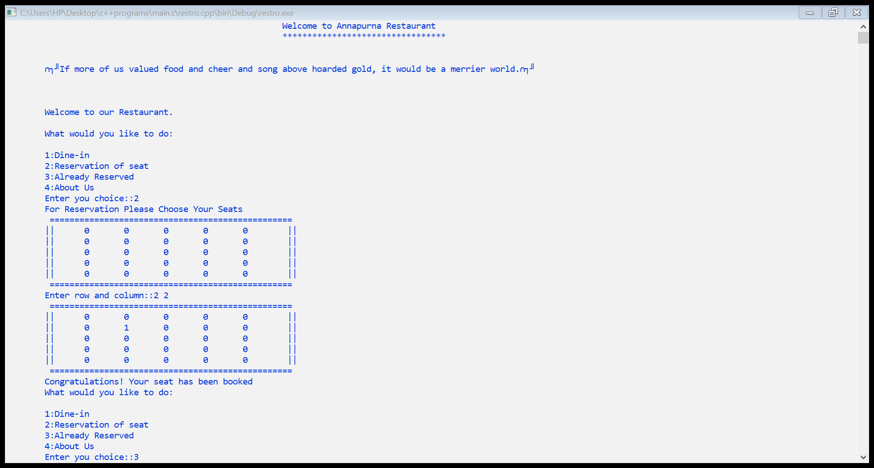

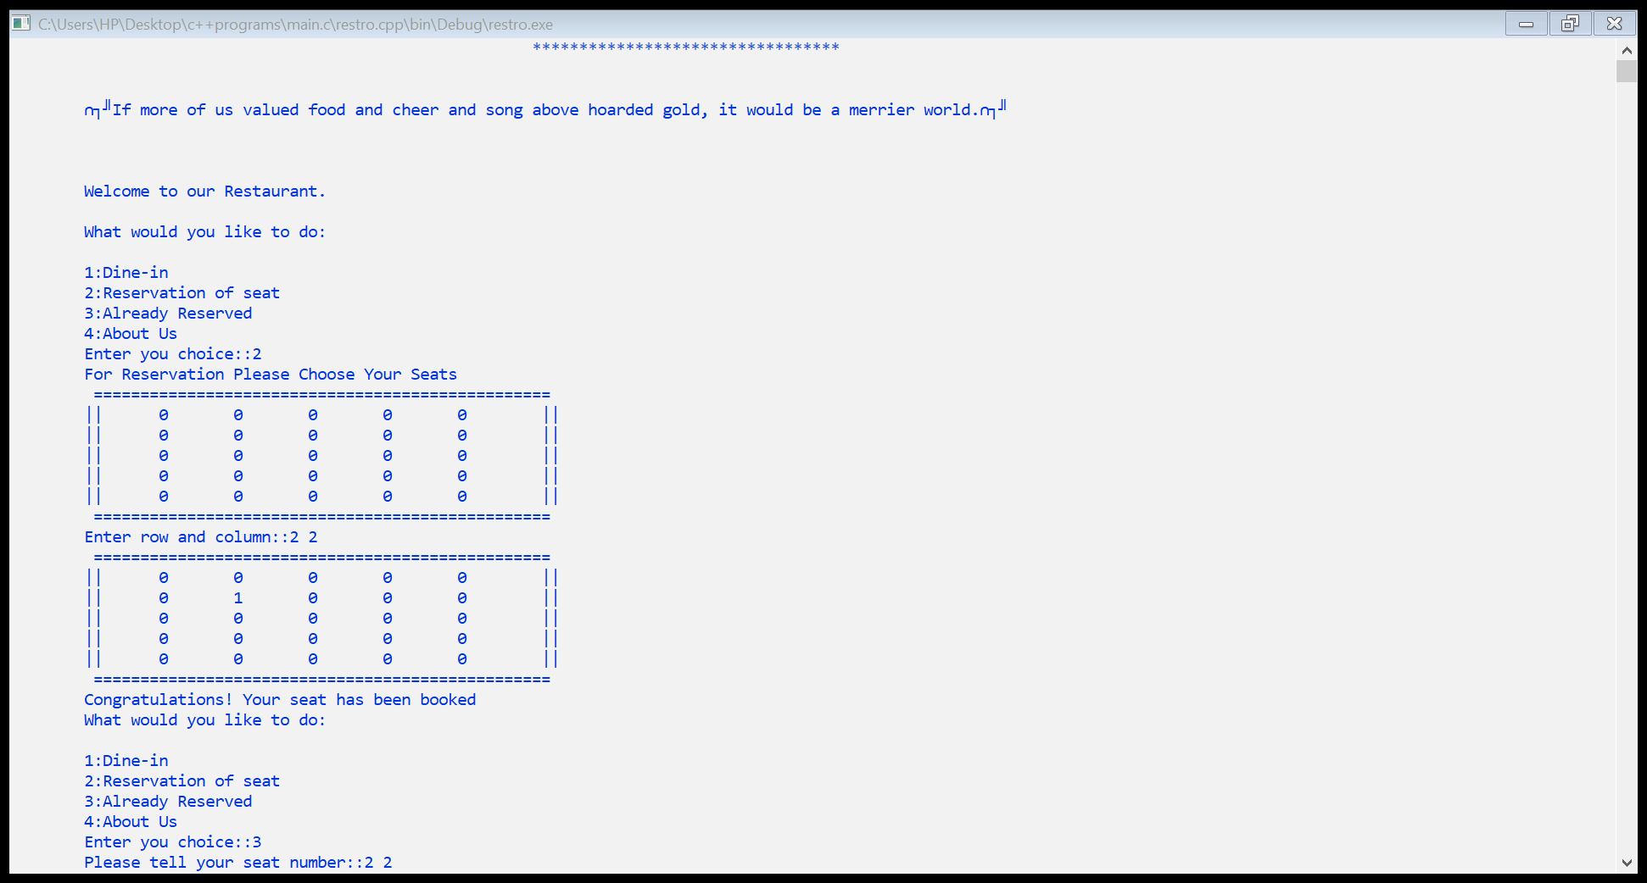

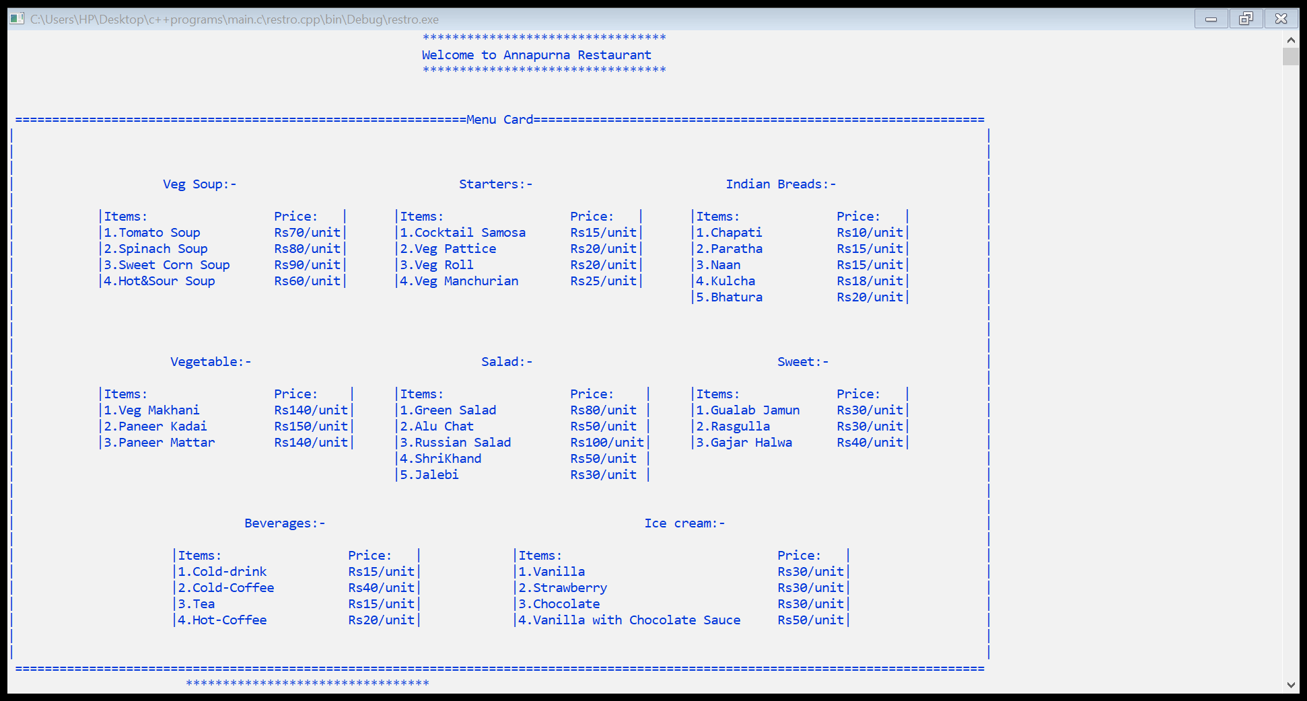

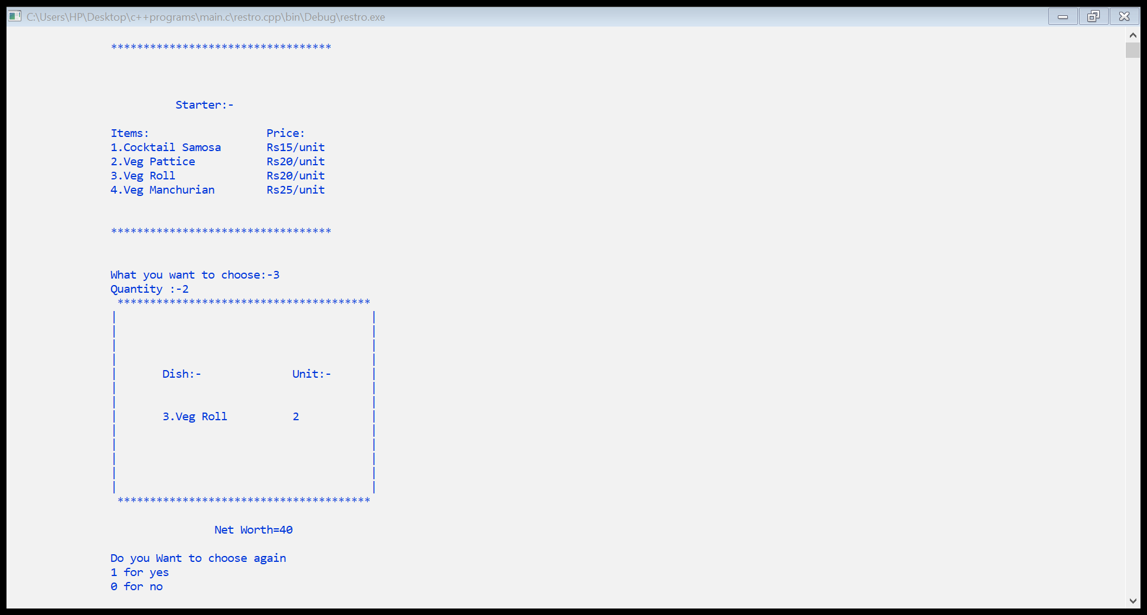

# C:\Users\HP\Desktop\c++programs\main.c\restro.cpp\bin\Debug\restro.exe

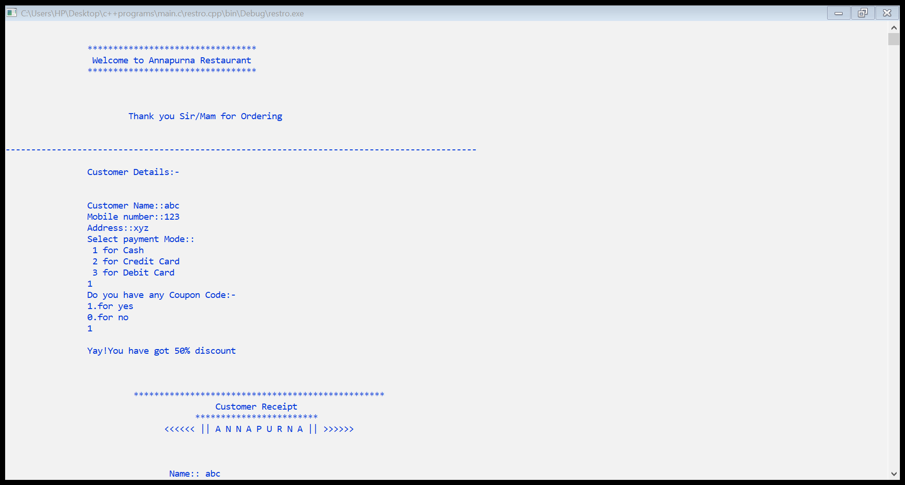

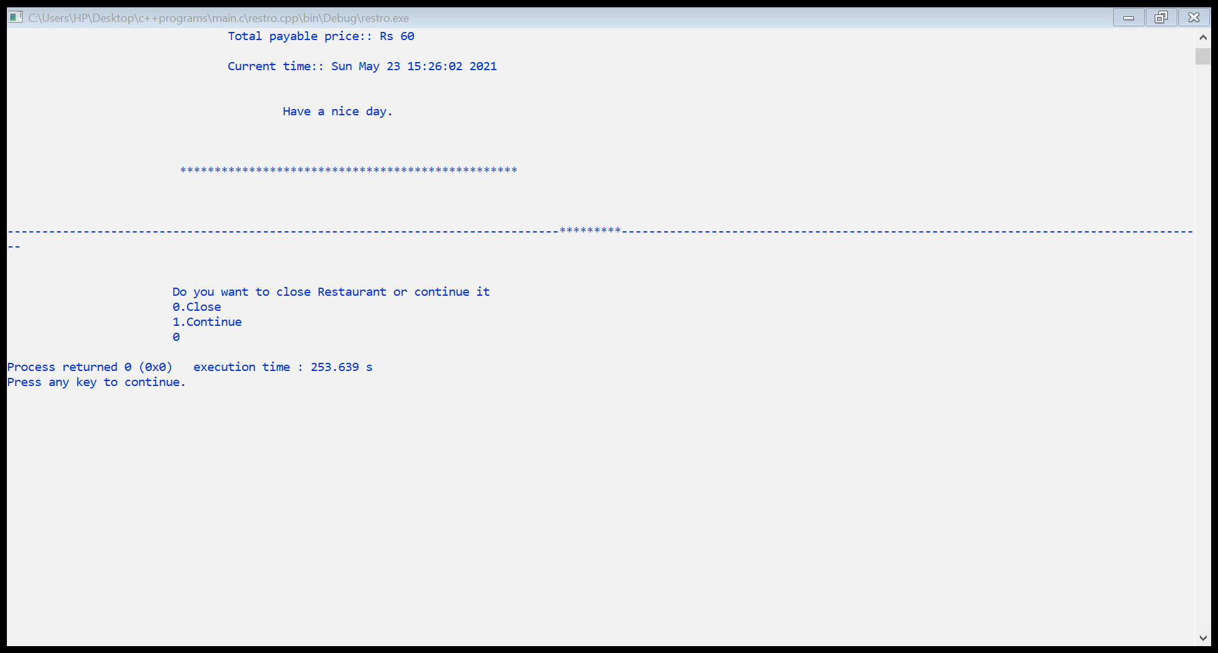

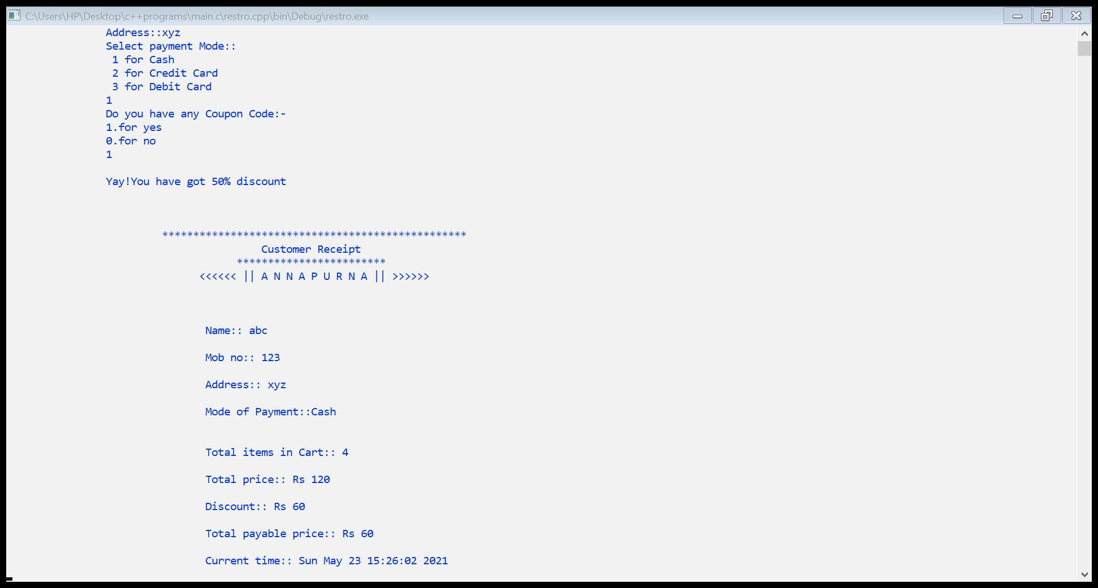

***Conclusion :-***

The project entitled "RESTAURANT MANAGEMENT SYSTEM" has been proposed to be implementing to replace the manual system.

• The developed system accomplishes all the objectives stated for the need for the change of the system.

• The project is user friendly.

• Different principles of OOP have been implemented in this program.

• Although graphics has not been used in this project, the user defined functions produce a satisfactory output.

***References :-***

• <https://www.geeksforgeeks.org/>

• <https://www.tutorialspoint.com>

• <https://www.javatpoint.com/>

• <https://code-projects.org/restaurant-management-in-c-c-with-source-code/>

• <https://online.visual-paradigm.com/>